4.1 Double Integrals

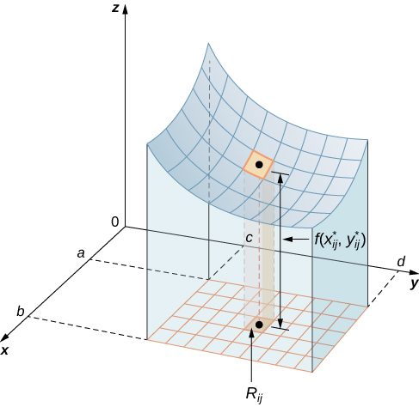
Motivation: Consider a functionof two variables defined on a closed rectangle: . Suppose that on R.

Suppose we want to find the volume of the three dimensional solid that is bounded below by R and above by the blue surface determined by f. One should note that if we allow to be negative we would be finding a signed volume.

To do this we will partition the interval on the x axis and the interval y axis using equal spaces of and . This will partition the rectangle R into smaller rectangles

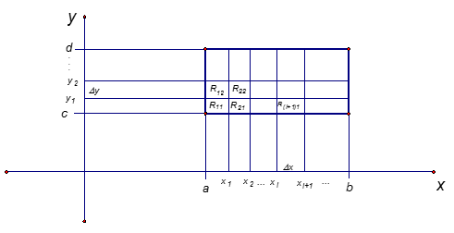

We note that since the intervals were partitioned with equal spaces (the picture is not to scale), each rectangle has an area of .

Our idea to approximate the desired volume is to use rectangular prisms with bases that are the small rectangles within R. To determine the height of each rectangular prism we use a sample point in each rectangle and let the height of the rectangular prism with base be so that the rectangular prism’s top intersects the surface determined by . This means that the volume of the rectangular prism with base is .

So, if and , the approximation for the desired volume becomes:

The really important idea is that as the partitions get finer and finer, that is and , this approximation ought to approach the actual desired volume! This idea leads to the following definitions.
Definition: The (signed) volume of the solid that lies under (or over) the graph of and above (or below) the rectangle R is

Definition: The double integral of over the rectangle R is
if this limit exists.

Definition: A function is called integrable if the limit in the above definition exists.

Note: It is possible to prove (usually done in real analysis) that all continuous functions are integrable.

Example 1: Based upon your knowledge of what the double integral measures, explain in words the geometrical meaning of the quantity: .
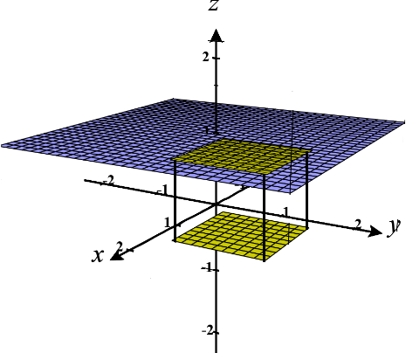
Here the function of integration is 1, and the graph of is the plane . Geometrically the portion of the plane over a rectangle R is another rectangle with the same dimensions as R. So, is the volume of the rectangular prism with base R and height 1. This means that it also yields the area of R!

In Calculus I one learns that definite integrals are difficult to calculate directly from the definition of Riemann sums. Then, quite fantastically, one learns about the Fundamental Theorem of Calculus which helps one calculate many definite integrals in an efficient way.

The definition of double integral that we introduced above is also quite difficult to use to evaluate a double integral. We will now learn about the awesome result that double integrals, in many situations, can be thought of as something called iterated integrals. This will help us tremendously in evaluating double integrals.

We begin by introducing the concept of iterated integral. Then, we will make a connection between iterated and double integrals.

Definition: Suppose that is a function of two variables that is integrable on the rectangle . We refer to the following integral as an iterated integral: .

Note: To find the innermost integral we view x as a constant and integrate with respect to y.
Note: It is possible that the differentials can switch positions.
Example 2: Evaluate the iterated integral (be exact): .
Starting with the innermost integral we calculate that

Example 3: Evaluate the iterated integral (be exact): .
Starting with the innermost integral we calculate that

Note: The above example is very similar to the first example. The only difference is that the differentials and limits of integration are reversed. Even under this change we obtained the same value for the iterated integral.

The next theorem will explain why the iterated integrals in the first and second example have the same value. It will also be the key to connecting the ideas of the double integral and the iterated integral we have been discussing in this section.

Theorem (Fubini’s Theorem):
If is continuous on the rectangle , then
.
More generally, the above equations hold if we assume that is bounded on , is discontinuous only on a finite number of smooth curves, and the iterated integrals exist.

Proof: Beyond the scope of the course
Note: Much like the Fundamental Theorem of Calculus connects integration and differentiation, Fubini’s theorem connects the concept of double integral with the concept of iterated integral.

Example 4: Evaluate the double integral , where .

By Fubini’s Theorem we know that
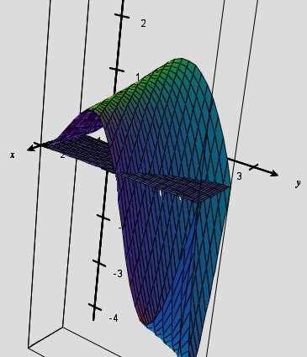
One should understand that 0 represents the signed volume of the solid bounded by R and the function (signed volume means that any part of the solid below the xy-plane is counted as having negative volume. A picture of R and is shown at the right.

Note: The order of the differentials in the solution of the above example was carefully chosen. One could have solved the above example by evaluating the iterated integral: . However, evaluating this iterated integral requires the use of integration by parts, and we are able to avoid using integration by parts if we put dx in our innermost integral.

Example 5: Find the volume of the solid that lies under the hyperbolic paraboloid given by and above the rectangle .

Based upon what we know about double integrals, the volume is . By Fubini’s theorem we know that:

